**Document Control**

|  |  |
| --- | --- |
| Project Manager | Graham Pugh |
| Document Author | Manickarajan Subramanian |
| Date | 08/02/2021 |
| Version | 0.4 |
| Classification | Experian Confidential |

**UK &I Solution Division**

**DCI Legacy Test Approach**

Document Owner

|  |  |
| --- | --- |
| Name | Role |
| Manickarajan Subramanian | Test Lead |

Approval

Following approval, this document will be base lined by promoting it to a major version number (e.g. 1.0), recording the names and positions of approvers in the Approval Record and, if applicable, accepting all tracked changes. The Approval Record can be found in the Document Control Appendix at the end of this document.

A soft copy of email approvals will be maintained and stored as a permanent record of acceptance of this document.

Change Control

This document is subject to change control. All requests for change should be referred to the document owner.

The Change History can be found in the Document Control Appendix at the end of this document.

Distribution

|  |  |  |  |
| --- | --- | --- | --- |
| Name | Role | Reason | Departments |
| Graham Pugh | Project Manager |  |  |
| Jonathan Hollis | Delivery Manager |  |  |

**Contents**

1. Introduction 4

1.1 Document Purpose 4

1.2 References 4

1.3 Project / Solution Overview 4

2. Scope 4

2.1 In Scope 4

2.2 Out of scope 5

3. Test Approach 5

3.1 Test Basis 5

3.2 Test Design 5

3.2.1 Manual Test case Design 5

3.2.2 Automated Test case Design 6

3.3 Test Execution 6

3.3.1 In Scope 6

3.3.2 Out of Scope 7

3.4 Test Environment Requirements 7

3.4.1 Security Testing 7

3.4.2 Regression Testing 7

3.4.3 Browser Compatibility Testing 7

3.5 Test Data 8

3.6 Test Tool Requirements 8

3.7 Defect Management 8

3.7.1 Defect Workflow 8

3.7.2 Defect Triage Roles 8

3.7.3 Defect Priorities 9

3.7.4 Defect SLAs 9

3.8 Suspension & Resumption Criteria 9

3.8.1 Suspension Criteria: 10

3.8.2 Resumption Criteria: 10

4. Roles and Responsibilities 10

5. Test Closure and Approval Process 10

6. Risks and Issues 11

6.1 Risks 11

6.2 Issues 11

6.3 Risk Governance 11

7. Test Deliverables 11

8. Appendices 11

8.1 Appendix A Glossary of terms and abbreviations 11

8.2 Appendix B – Defect Workflow 12

8.3 Appendix C – Legacy Applications 12

8.4 Appendix D - Document Control 13

# Introduction

## Document Purpose

The Test Approach document is intended to provide its readers with a comprehensive view of the tactical approach adopted to test DCI Legacy applications by detailing the high-level features and components that will be tested. It outlines the feasibility and effort required to create testing processes to address all security requirements of DCI Legacy applications. This document details on the test approach by defining the test methodologies, test processes and test requirements specific to the project. It encapsulates the different test approaches adopted, specifications on the test environment, test data management processes and defect management process.

## References

Below is the list of all documents that support this Test Approach.

|  |  |
| --- | --- |
| Document Title | Version |
| JIRA Projects | [Security Test - Agile Board - Agile Jira (experian.com)](https://agile.experian.com/secure/RapidBoard.jspa?projectKey=DCL&rapidView=26640) |
| SharePoint | <https://experian.sharepoint.com/sites/CyberSecurityUpgrades/SitePages/Home.aspx> |

## Project / Solution Overview

The project is about security testing of the DCI Legacy applications to align with the Experian Security policy. To make these products compliant, each product will undergo static scans and Penetration testing.

If any vulnerability found as part of static scan or Penetration testing, then these products will undergo remediation work to address any security vulnerabilities. DCI Legacy applications also have scope for enhancement of the application functionality and decommissioning the applications which is not in regular client use.

There are 220 applications are in scope for Pen Test and Veracode Fixes. Only 45 logical applications are in scope for testing.



# Scope

## In Scope

Types of testing that are in scope for the QA Team.

* Build Verification Testing
* Automated Regression Execution
* Manual Regression Execution (if ARP not available)
* Browser Compatibility Testing (To test the Legacy applications with Edge Browser in IE mode)

|  |  |
| --- | --- |
| **Pen Test and Static Scan Vulnerability Fix Testing** | |
| **Owner** | QA Team |
| **Test Objective** | To ensure application security. |
| **Scope** | To cover security tests of the application based on the changes that are received. |
| **Technique** | Security testing. |
| **Test Levels & Test Types** | Pre- Testing, Post Testing, BVT & Regression testing |
| **Test Deliverables** | Test Approach, Test Cases, RTM, QGR |
| **Entry Criteria** | Receive the application with code changes once Unit testing completed from Development team with QGR approved. |
| **Exit Criteria** | Get QGR approved for QAT and request to promote the build to UAT. |

## Out of scope

The following items are out of Scope for the QA team.

* Unit Testing
* Functional Testing
* User Acceptance Testing
* Non-Functional Testing

# Test Approach

DCI Legacy team adopted Agile methodology to test multiple applications using Kanban board to cover the security test and regression test of each application.

## Test Basis

Below list of project documentation, which should be referred as the test basis.

* + QAT Environment and Credentials
  + User Guide
  + Pen Test Reports

## Test Design

### Manual Test case Design

The following approach planned for test case design.

* Identify the regression test cases and prepare the test data.
* Get BA reviewed and receive sign off on the Regression coverage.
* Pre-Run on application to ensure the production version of code it has.
* Save the Pre-test logs in SharePoint.

### Automated Test case Design

The DCI Legacy application regression test cases will be automated using the ETAF(Experian Test Automation Framework) . The detailed ETAF architecture diagram is given below.

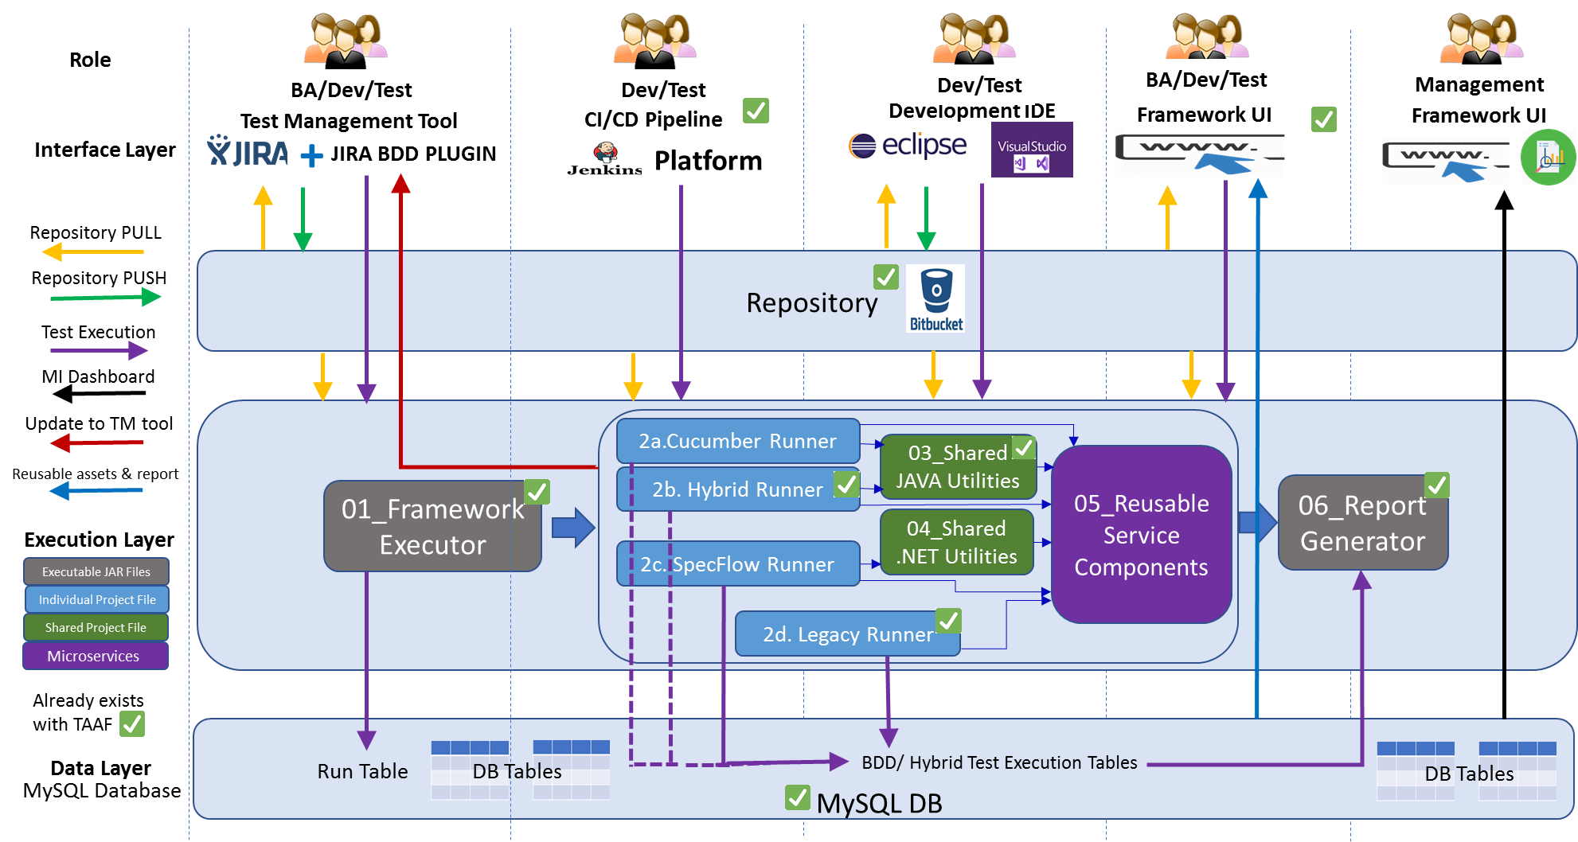

There are two approaches for automating the regression suites for applications under scope.

* First approach is to use the ETAF Hybrid framework to automate UI Applications regression test cases.

In Hybrid Framework approach, team will analyse the existing regression suites and will create Keyword driven tests for the same. The test will upload in the cloud environment and user can run the script from ETAF UI.

* Second approach is to follow the ETAF BDD frameworks Cucumber Runner to automate the API applications.

## Test Execution

### In Scope

The below testing will be performed as part of the security fixes of the DCI Legacy applications.

* Build Verification Testing
* Automated Regression Testing
* Manual Regression Testing (if ARP not available)
* Browser Compatibility Testing (To test the Legacy applications with Edge Browser in IE mode)

All test results will be recorded in JIRA which records the result, who executed the test case and when the result was updated.

Any failed tests will have a corresponding defect raised in JIRA which will be linked to the test result.

In addition to capturing the test result and any associated defects, test evidence will routinely be collected for all Pen test and Static scan vulnerability fix testing.

|  |  |
| --- | --- |
| **Pen Test and Static Scan Vulnerability Fix Testing** | |
| **Owner** | QA Team |
| **Test Objective** | To ensure application security. |
| **Scope** | To cover security tests of the application based on the changes that are received. |
| **Technique** | Security testing. |
| **Test Levels & Test Types** | Pre- Testing, Post Testing, BVT & Regression testing |
| **Test Deliverables** | Test Approach, Test Cases, RTM, QGR |
| **Entry Criteria** | Receive the application with code changes once Unit testing completed from Development team with QGR approved. |
| **Exit Criteria** | Get QGR approved for QAT and request to promote the build to UAT. |

### Out of Scope

The following items are out of Scope for the QA team.

* Unit Testing
* Functional testing.
* User Acceptance Testing
* Non-Functional Testing

## Test Environment Requirements

### Security Testing

Security fixes testing will be performed on the QAT environment. Since the QAT environment setup is not available for the Strategic-eSeries applications, testing will be performed on the UAT environment.

### Regression Testing

The regression testing will be performed on the QAT environment. Since the QAT environment setup is not available for the Strategic-eSeries applications, regression testing will be performed on the UAT environment.

### Browser Compatibility Testing

The Browser Compatibility testing will be performed by running the regression pack on the QAT environment with Edge browser an IE Compatibility mode for the Legacy UI applications. Please refer Appendix C for the list of Legacy applications to be tested for the Edge browser compatibility.

## Test Data

There are three approaches towards test data.

* Get the test data from the regression cases wherever possible.
* Collect test data from ExPIN databases wherever possible.
* Obtain exception approval where no test data is available.

## Test Tool Requirements

|  |  |
| --- | --- |
| **Activity** | **Tool** |
| Test Case Management | JIRA with Zephyr |
| Defect management | JIRA Global |
| Automation | TAAF (JAVA, Selenium) |

## Defect Management

All defects will be triaged based on the severity and priority. Each defect points will be discussed, and captured evidences can be referred during this meeting to take a decision on the logged defects. Necessary advice from business and BA may require for some defects to confirm validity.

The frequency of the triage is set to daily. However, the triage sessions can be cancelled if there are no defects to triage.

### Defect Workflow

The standard defect workflow diagram is shown in the Appendices has been built into Jira Global.

Defects are initially triaged to check the validity of the defect, and to make sure the appropriate levels of Severity and Priority have been applied. The Defect will then be assigned to the resolver.

Test Lead will own the defect triage process which usually takes the form of a daily conference call or Teams meeting between Developers, Project BA and Test Analysts.

### Defect Triage Roles

|  |  |
| --- | --- |
| Role | Responsibility |
| Test Analysts | Submission of Bug Report |
| Test Lead | Convene Defect Triage Meetings |
| Development Lead | Assessment of Bug Report |
| Developers | Clarifications of bug if any |
| Business Analysts | Confirmation of bug |

### Defect Priorities

The importance or urgency of fixing a defect, this will be set by the Tester initially and Test Lead can re-prioritise based on the Defect Triage meetings. During the Defect Triage meeting an assessment as to how disruptive to the testing schedule the continued existence of the defect in the test environment is may drive the priority of the defect.

|  |  |
| --- | --- |
| Priority | Description |
| Blocker | Show Stopper: This prevents business from continuing, e.g.:  Entire System or Key business process is unusable or does not meet the needs of the business  Many users affected and no work-around is available  Loss of data occurs that is not immediately recoverable and prevents the business from continuing |
| Critical | The problem affects selected processing to a significant degree, making it inoperable, causes data loss, or could cause a user to make an incorrect decision or entry, e.g.:  Part of the system or key business process is unusable or does not meet the needs of the business  Few users affected but a work-around is available  Corruption or loss of data occurs that is immediately recoverable and allows the business to continue |
| Major | The problem affects selected processing but has a work-around that allows continued processing and testing. No data loss is suffered, e.g.:  A non- critical incident occurs, typically affecting a single user  The incident affects the ability to provide the best service but there is a workaround |
| Minor | Testing can continue. Includes problems which do not allow testers to perform a minor function or process which does not need a workaround. |
| Trivial | The problem is cosmetic, and/or does not affect further processing and testing, e.g.:  Cosmetic errors  Minor anomalies in documentation  Requests for information or advice |

### Defect SLAs

|  |  |
| --- | --- |
| Priority | SLA |
| Blocker | Fix required within 4 hours |
| Critical | Fix required within 8 hours |
| Major | Fix required next build / patch. |
| Minor | Fix required next build / patch. |
| Trivial | Fix required next build / patch. |

## Suspension & Resumption Criteria

Test Leads may recommend the suspension of testing for any of the following reasons:

### Suspension Criteria:

* A defect is introduced that stops any further testing, e.g. a severity 1 defect is raised for a catastrophic failure of the system functionality and renders the solution unusable and where no acceptable workaround has been identified.
* The number of open defects produces a situation where they cumulatively mean testing has no value at a given point in time.
* The unavailability of dependent systems during test execution that results in all tests being blocked, i.e. no tests can be executed.
* When the entry criterion is not met or being dynamic and undergoing changes for any test stage for testing types in scope.

### Resumption Criteria:

* When the defect is resolved and retest on the fix, or new code, is successful, i.e. the defect has been successfully retested and can be closed.
* When the dependent systems become available again.
* When agreed by the relevant stakeholders of the programme/project.

# Roles and Responsibilities

|  |  |
| --- | --- |
| Test Lead | Overall Ownership of delivery from testing side  Involvement in Automation & Manual test Development / Execution Review |
| Test Analysts | Manual test design and execution  Automated Test Execution |
| Automation Analyst | Automated Test Design & Execution  Framework Updating and Maintenance |

# Test Closure and Approval Process

A Quality Gate Report will be produced at the end of the Testing and will summarise all testing up to that point, providing both commentary and statistics of the test results.

The report will also detail defect statistics including commentary on outstanding defects and their planned resolutions.

The approval of this report by the Project Manager is a mandatory requirement to officially close the testing activities.

# Risks and Issues

## Risks

|  |  |  |
| --- | --- | --- |
| **RAID ID** | **Description** | **Mitigating Action** |
| TBC | MRP creation is on hold due to the UKCS Cerberus RMS (H3G) application error on the QAT environment | Work with dev team and Application support to resolve the issue |
| TBC | MRP creation is on hold due to the eSeries - cawiseconsumer application error on the QAT environment | Work with dev team and Application support to resolve the issue |

## Issues

|  |  |  |
| --- | --- | --- |
| **RAID ID** | **Description** | **Mitigating Action** |
| TBC | Strategic e-Series applications are not setup in QAT environment | Testing will be done on the UAT environment. |

## Risk Governance

* Risks identified during the project shall be monitored by the project team and discussed with the project stakeholders during the weekly status review meetings, and shall be reported in the Daily and Weekly status reports

# Test Deliverables

| **Deliverables** | **Role/s Responsible** | **Reviewers** | **Approvers** |
| --- | --- | --- | --- |
| Manual Regression Pack | Test Analyst | Project Manager | Project Manager |
| Automated Regression Pack | Automation Test Analyst | Project Manager | Project Manager |
| Weekly Status Report | Test Lead | Project Manager | Project Manager |
| Quality Gate Report | Test Lead | Project Manager  Delivery Manager | Project Manager  Delivery Manager |

# Appendices

## Appendix A Glossary of terms and abbreviations

|  |  |
| --- | --- |
| BVT | Build Verification Testing |
| RTM | Requirement Traceability Matrix |
| QGR | Quality Gate Report |
|  |  |

## 

## Appendix B – Defect Workflow

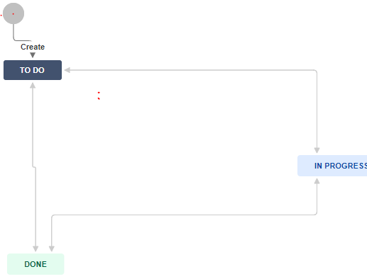

## Appendix C – Legacy Applications

|  |  |
| --- | --- |
| App ID | Application Name |
| 1603 | eCabinetview (eSeries .net platform) |
| 1606 | UKCS e-ConsumerView Ireland |
| 1608 | Forceview (eSeries .net backend) |
| 2214 | UKCS Cerberus RMS (H3G) |
| 7271 | UKCS CEMS Blueprint (Virgin Money) |
| 7272 | Blueprint (Wesleyan Bank) |
| 7273 | Blueprint (Sulco Services) |
| 7274 | Blueprint (Scottish Power) |
| 7275 | Blueprint (Green Deal Finance) |
| 7276 | Blueprint (Credit Union Company) |
| 7381 | WASP |
| 8117 | eSeries - cawiseconsumer |
| 8203 | WASP Certificate Enrolment Portal |
| 8204 | WASP Certificate Administration Site |
| 8205 | WASP Certificate Conversion Administration Site |
| 8206 | WASP Certificate Conversion Site |

## Appendix D - Document Control

Change History

|  |  |  |  |
| --- | --- | --- | --- |
| Date | Version | Author | Details |
| 26/1/2021 | Draft | Manickarajan Subramanian | Initial Draft |
| 29/1/2021 | 0.2 | Manickarajan Subramanian | Updated review comments |
| 1/2/2021 | 0.3 | Manickarajan Subramanian | Updated review comments |
| 8/2/2021 | 0.4 | Manickarajan Subramanian | Included Browser Compatibility Testing |

Approval Record

|  |  |  |
| --- | --- | --- |
| Major Version | Approved By | Departments |
|  |  |  |
|  |  |  |
|  |  |  |

Distribution for Current Version

|  |  |  |  |
| --- | --- | --- | --- |
| Name | Role | Departments | Reason |
| Graham Pugh | Project Manager |  | Approval |
| Jonathan Hollis | Delivery Manager |  | Review |
|  |  |  |  |
|  |  |  |  |